Pre-Reading

Package
There are many new words in this reading. The first word we’ll see is 站起来 (zhan4qi3lai2) this has the same meaning as 起立 (qi3li4) or stand up. 起立 is usually used in the classroom setting where as 站起来 is used elsewhere. Now let’s look at the characters, the first character 站 has the 立 character on the left which means to stand, 站 is also the character used for bus stop, 公车站. The next character is 然后 (ran2hou4) it should be review, it means “and then.” The next character is a directional character, it is 进 (jin4). 进 means “to enter” you will often see this character with other action characters such as 走进 walk into, 跑进 run into, and 飞进fly into. Often times these phrases will also add a 去for extra emphasis. There are several countries that are listed in this article, if you first say them out loud you may be able to guess their meaning. 西班牙(xi1ban1ya4)，墨西哥 (mo4xi1ge1)，新加坡 (xin1jia1po1)，印度 (yin4du4)，埃及 (ai1ji2). The first one 西班牙is Spain, if you add 语 to the end of 西班牙 then you get Spanish. The second character 墨西哥 is Mexico. These words are all phonetically, characters are selected to try and imitate the sound of the countries name. The next country 新加坡 is Singapore and the last two 印度 and 埃及are India and Egypt respectively. The next concept is a little hard， 从来不 (cong2lai2bu4) means “to never have done something” you can also say 从来没, usually the distinction between 不and 没 is as simple as present and past tense respectively, but there are some words that take 不and not 没 and visa-versa, for example you cannot say 不有 and you can’t say 没知道 for these words you can think of 不 as being used to express subjective things and 没 as being more objective. So 我没有is present tense but it is objective, 我不知道 this is subjective because it depends on you and what you know. The next word is 语言 the first character 语 you should recognize as the language character, when it is with 言 it simply means language. The next word is 国家 (guo2jia1) ， the first character 国 has a border around the middle part, this tells us that the character has to do with an enclosure. 国 means nation, the 家means home, together they mean country. The next word 地址（di4zhi3）simply means address, you can note that both characters have the 土 character, 土 means land, dirt, or ground. The next phrase we have is 看上去, these characters you should all recognize, together they mean “to look like” or “seem like” we can also change the first character so that we have 听上去or sounds like, or we could also say 闻上去smells like. The next word is 寄包裹 (ji4bao1guo3) which is to send a package. Pay attention to the 寄 which means to send, but it is usually used to send things via the mail, if you send a text message or email you would use 发.
Story Character Count = 101

Vocabulary/Writing

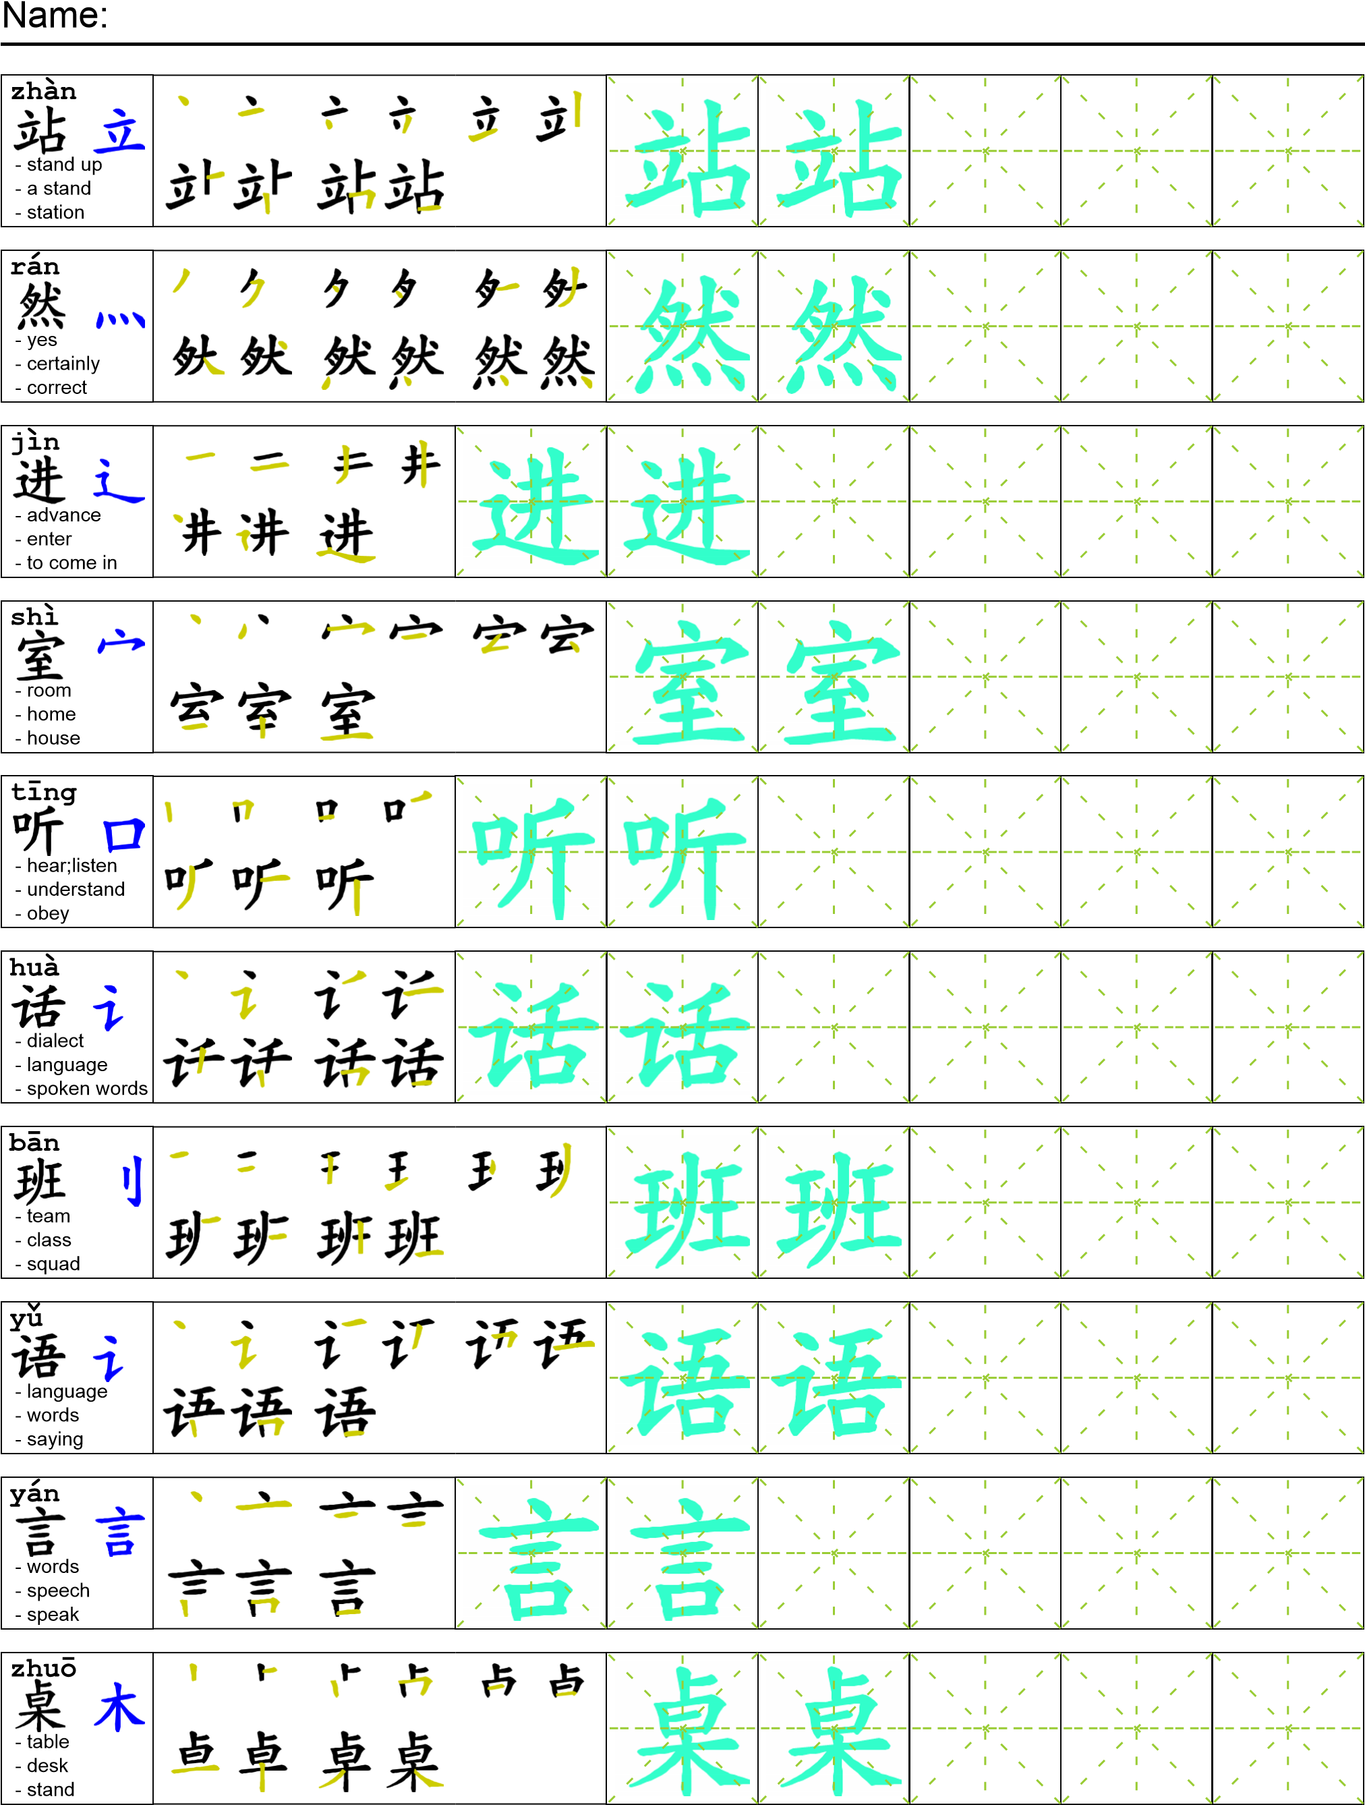
Reading

我妈妈突然站起来，然后走进了她的卧室。我听到她在电话里开始说西班牙语。我从来不知道她会说别的语言。然后我发现在桌子上有很多不同国家的地址。看上去她要给这些国家寄包裹。纸上写得墨西哥，新加坡，印度，埃及还有很多别的国家。

Task Completion

Once all tasks are complete turn the assignment in to collect the points for the project.
Task 1: Trace the vocabulary and copy the text into your notebook.

Task 2: Answer Comprehension Questions.

Task 3: Write the Pinyin for the Reading.

Task 4: Translate the Reading into English.

Task 5: Record yourself reading the passage.

Comprehension Questions
- Use 看上去 to make two sentences.
- What does the author find out about his mother?
- What countries was written on the piece paper?
- What is another way to say 起立?

